Which of Travelzoo’s Top 5 Markets produces the most Transactions with every additional Live Deal?

**Problem:** Travelzoo.com sells Vouchers in markets across the US. Travelzoo’s 5 largest markets in the past year are Chicago, Los Angeles, New York City, Los Angeles and Washington DC. If Travelzoo were to add a single additional Voucher Deal to any of these 5 markets, which would provide the most transactions in return?

**Hypothesis:** I think New York City is our most popular market and will provide the most Transactions if we were to add another Deal.

**Analysis:** The # of Transactions and # of Live Deals for the past 25 months (January 2014-February 2016) was gathered for each Market. All 125 data points were put onto 1 Scatterplot to check for Outliers. Data looks uniform so data was broken up into 5 sets and linear regression was performed [See **Appendix A**].

5 Linear Regressions were performed for each of the 5 markets. We can then compare the X Coefficients and Confidence Intervals of the 5 to see which performed best [See **Appendix B**].

|  |  |  |  |  |  |
| --- | --- | --- | --- | --- | --- |
| Region | X Coefficient | SE | CI: min | CI: max | R^2 |
| Chicago | 66.041 | 3.259 | 59.299 | 72.783 | 0.947 |
| Los Angeles | 184.9043 | 9.637 | 164.969 | 204.84 | 0.941 |
| New York City | 289.0661 | 19.975 | 247.744 | 330.388 | 0.901 |
| San Francisco | 148.973 | 7.33 | 133.81 | 164.136 | 0.947 |
| Washington DC | 79.574 | 4.705 | 69.84 | 89.308 | 0.926 |
| All | 136.8308 | 6.464 | 124.037 | 149.624 | 0.783 |

New York City had the largest X Coefficient, meaning for every additional Live Deal added in NYC, we are 95% Confident that an additional 247.7 to 330.4 Transactions will take place. Chicago performed the worst of the 5, where for every additional Live Deal added in Chicago, we are 95% Confident that an additional 59.3 to 72.8 Transactions will take place.

**Conclusion:** Based on this data, Travelzoo should apply an additional Live Deal to the markets:

1. New York City
2. Los Angeles
3. San Francisco
4. Washington DC/Chicago

In order. Washington DC/Chicago are not statistically different as their Confidence Intervals Overlap.

**Appendix A:** All Regions

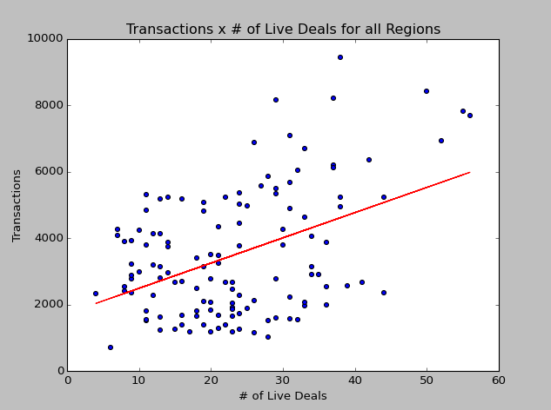

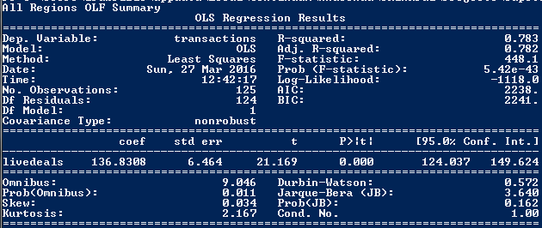

**Appendix B:** Individual Regions, in Alphabetical Order

